The Drone Flyers Club of The Villages
Shirts and Name Tags

You can get both of these items locally at Custom Apparel. They have our logo on file. You can buy a shirt in their store or bring in your own. Just make sure it has been washed and it is not stretch material.
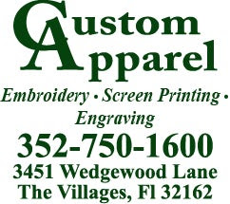

Name Tags: Approx $7 / Shirt Logo: Approx $14
